**Create a Notebook Session**

Data Science notebook sessions are interactive coding environments for building and training models. Notebook sessions provide access to a JupyterLab serverless environment that is managed by the Data Science service. All notebook sessions run in the Data Science service tenancy.

A notebook session is associated with a compute instance, VCN, subnet, and block storage. There are two block storage drives that are associated with a notebook session. There is a boot volume that is initialized each time the notebook session is activated. Any data on the boot volume is lost when the notebook session is deactivated or terminated. There is an additional block storage that is persisted when a notebook session is deactivated, but it is not persisted when a notebook session is terminated. This block volume is mounted in the /home/datascience directory and it is where the JupyterLab notebooks, data files, installed custom software, and other files should be stored.

When a notebook session is activated or created, the compute instance shape, block storage, VCN, and subnet are configured. These resources can only be changed by deactivating a notebook session, and then changing the configuration while activating the notebook session again. The size of the block storage can only be increased.

**Task 1: Creating a Notebook Session**

1. [Login to the OCI Console](https://www.oracle.com/cloud/sign-in.html).
2. Click the **Navigation Menu** in the upper left, navigate to **Developer Services**, and select **Stacks**.

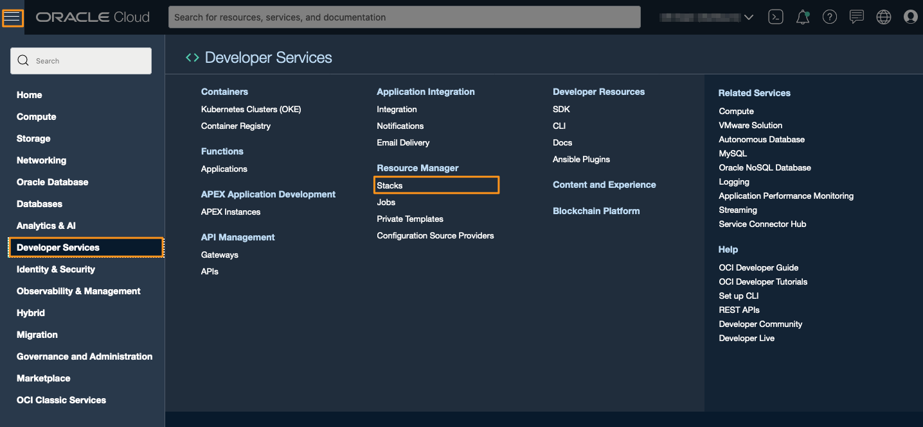

1. Select the compartment for the project.
2. Click the name of the project to contain the notebook session.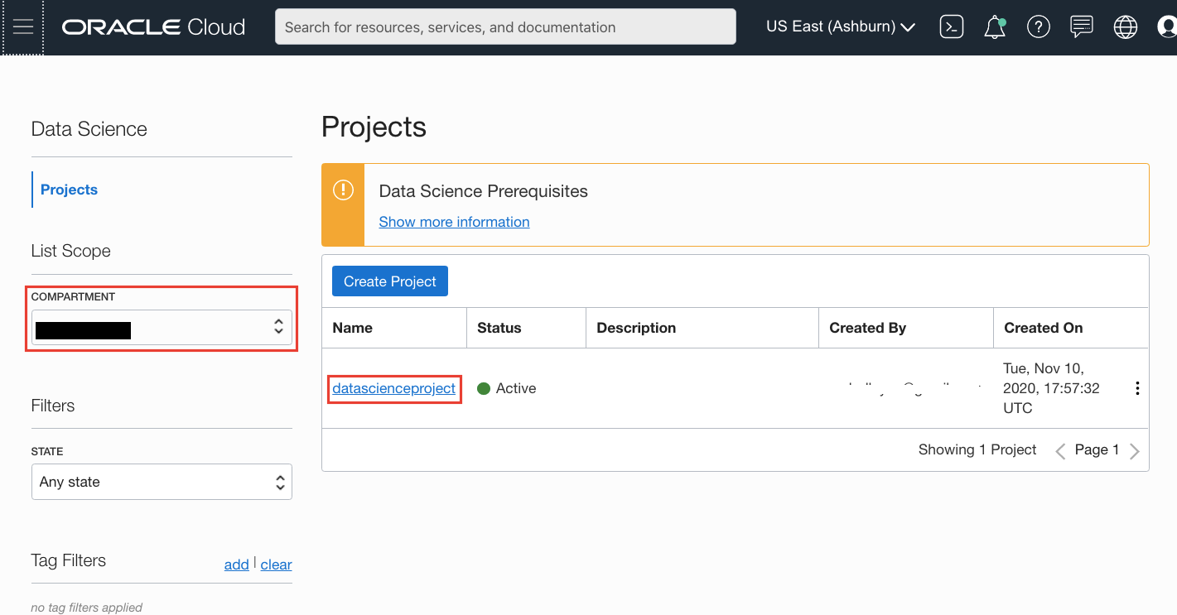
3. Click **Create Notebook Session**.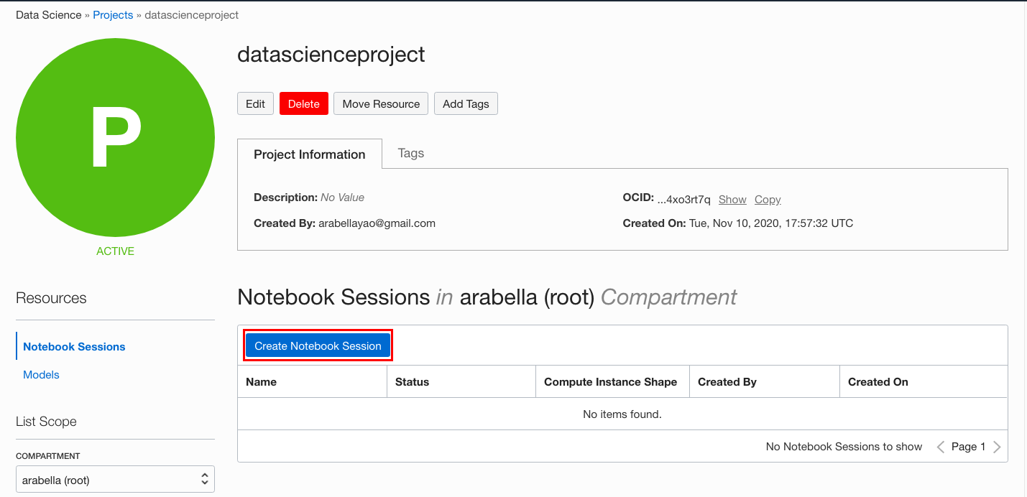
4. Select the compartment that you want to contain the notebook session.
5. (Optional, but recommended) Enter a unique name for the notebook session (limit of 255 characters). If you do not provide a name, a name is automatically generated for you.
6. Select a VM shape. The [Compute Shapes](https://docs.cloud.oracle.com/en-us/iaas/Content/Compute/References/computeshapes.htm) page has details on the specifications. For this lab, select a VM.Standard2.4.
7. Enter the block volume in GB. The suggested size is 100 Gb or larger.
8. Select the VCN compartment that contains the VCN that you want to use.
9. Select the VCN to use.
10. Select the subnet compartment that contains the subnet you want to use.
11. Select the subnet to use. Using a private subnet is recommended.
12. (Optional) Add tags to the notebook session by selecting a tag namespace, then entering the key and the value. You can add more tags to the compartment by clicking **+Additional Tags**, see [Working with Resource Tags](https://docs.cloud.oracle.com/iaas/Content/General/Concepts/resourcetags.htm#workingtags).
13. (Optional) View the details for your notebook session immediately after creation by selecting **VIEW DETAIL PAGE ON CLICKING CREATE.**.
14. Click **Create**.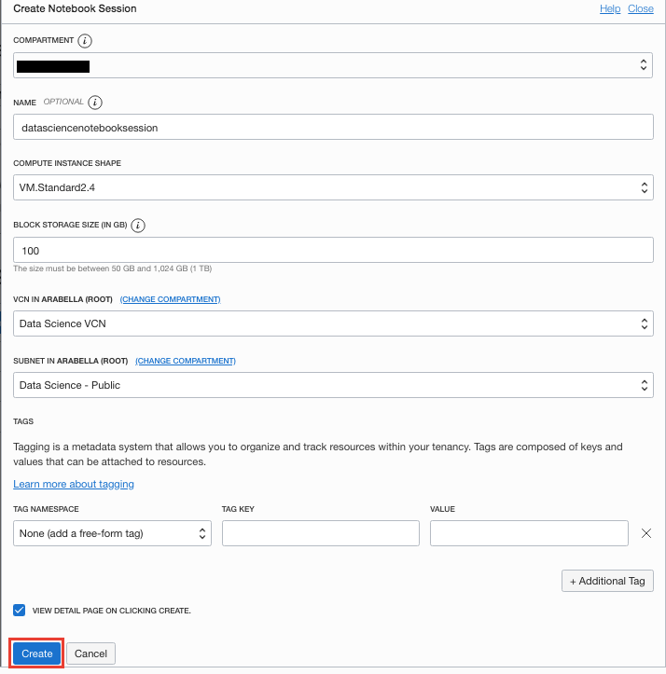

While the notebook session is being created, you can navigate away from the current page.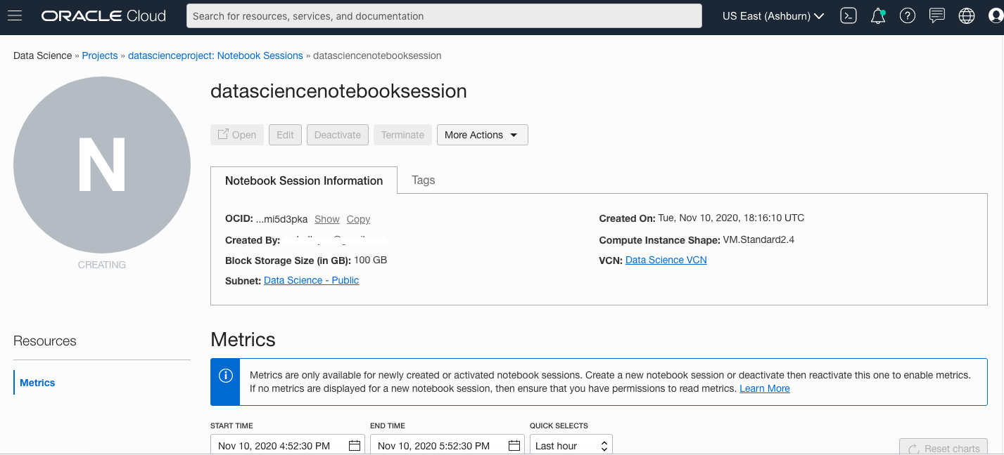

**Task 2: Opening a Notebook Session**

Once the notebook session has been created the notebook session page shows the notebook in an **Active** or **Inactive** state. To open the notebook:

1. [Login to the OCI Console](https://www.oracle.com/cloud/sign-in.html).
2. Click the **Navigation Menu** in the upper left, navigate to **Analytics & AI**, and select **Data Science**.

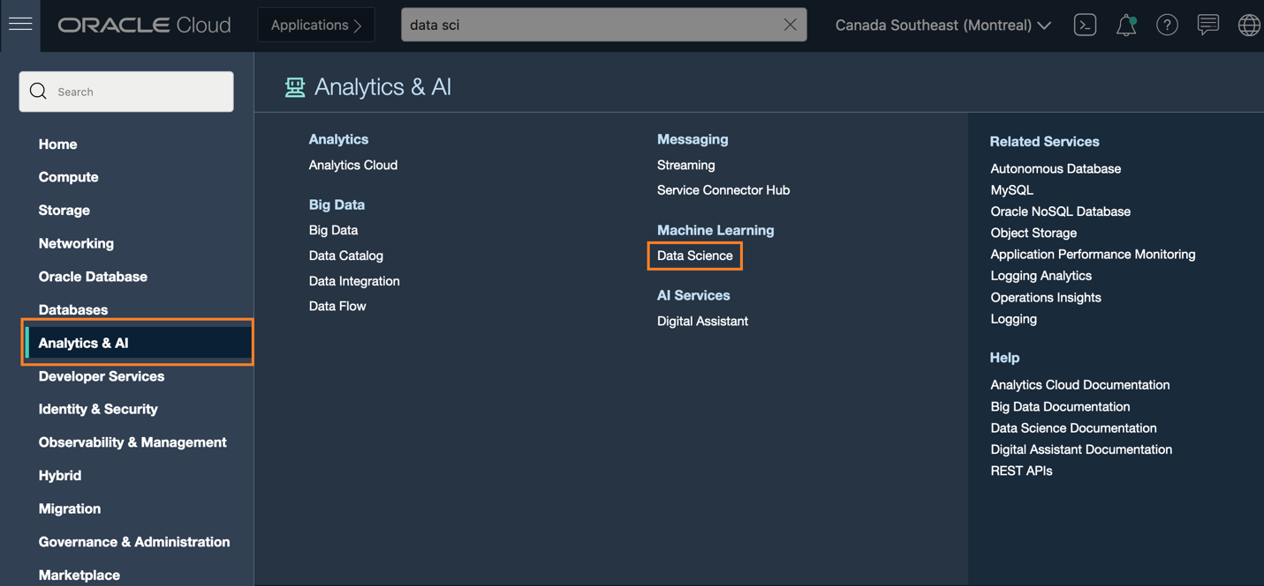

1. Select the compartment for the project.
2. Click the name of the project to contain the notebook session. This will open the Projects page.
3. Click the name of the notebook session. This will open the Notebook Session page.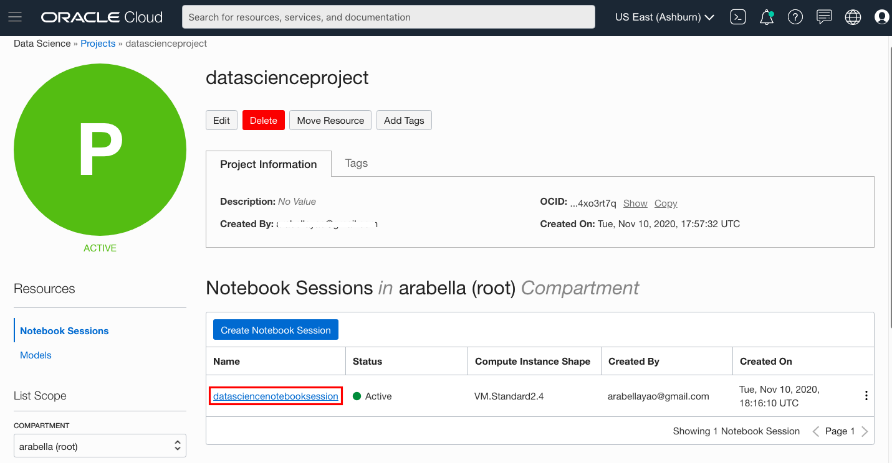
4. If the notebook is in an **Active** state, then click **Open**.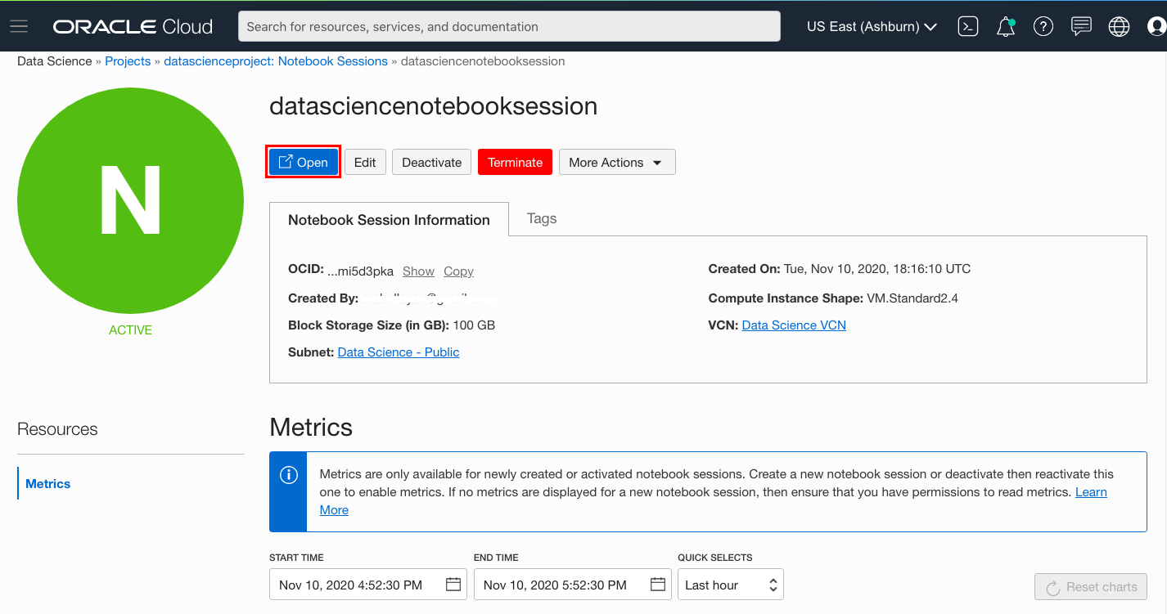
5. If the notebook is in an **Inactive** state, then:
   1. Click **Activate** to open the **Activate Notebook Session** dialog with the configuration from the last time the notebook session was activated or created.
   2. Select a VM shape. The [Compute Shapes](https://docs.cloud.oracle.com/en-us/iaas/Content/Compute/References/computeshapes.htm) page has details on the specifications. For this lab, select a VM.Standard2.4.
   3. Enter the block volume in GB. The suggested size is 100 Gb or larger. The size of the block storage can be increased, but not decreased.
   4. Select the VCN compartment that contains the VCN that you want to use.
   5. Select the VCN to use.
   6. Select the subnet compartment that contains the subnet that you want to use.
   7. Select the subnet to use. Using a private subnet is recommended.
   8. Click **Activate** and the notebook session status changes to **Updating**.
   9. When the notebook session status changes to **Active**, click **Open**